The Texas Concept Based Curriculum
What you need to know!

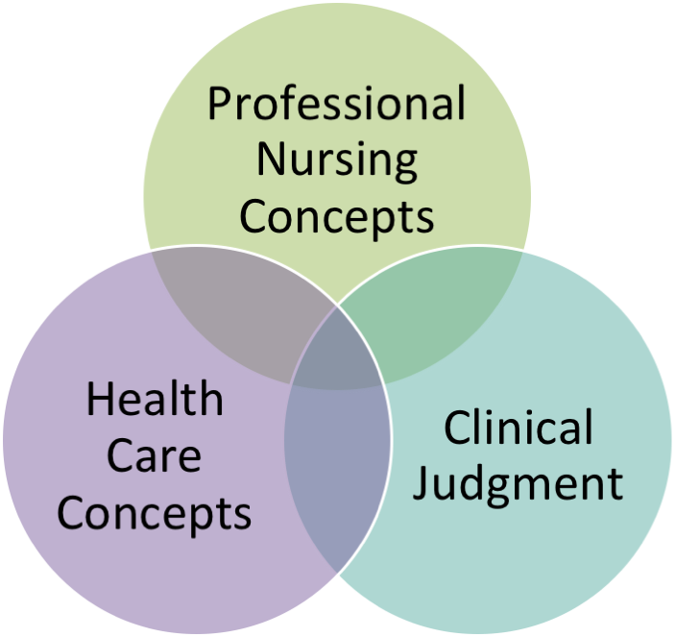
What is the Texas CBC?
The Texas CBC is a concept-based curriculum developed by faculty from twenty-eight schools in Texas, which is being implemented at 16 community colleges (started with 6 in the fall of 2013).

What are characteristics of a concept-based curriculum (Why did we go this route)?
- Allows for deep learning of concepts which helps promote development of clinical judgment
- Provides method for content management
- Maximizes efficiency and prevents content saturation
- Students focus on generalities of the concepts and then apply what they have learned to specific priority exemplars.
- Concepts can be applied in a variety of clinical settings, which will help utilize the current limited clinical sites and prepare graduates for a greater variety of positions.
- Emphasis on active learning activities
- Focus on conceptual learning - a process by which students learn how to organize information in logical mental structures challenging students to be coming increasingly skilled thinkers (Giddens)

What are the Texas concepts?
Texas concepts are divided into Health Care Concepts (biophysical and psychosocial) and Professional (nursing and health care). There are 43 concepts in the Texas CBC.

Biophysical
Acid base balance | Gas Exchange | Reproduction
Cellular regulation | Immunity | Sensory perception
Clotting | Intracranial regulation | Sexuality
Comfort | Metabolism | Sleep
Elimination | Mobility | Thermoregulation
Fluid and Electrolyte balance | Nutrition | Tissue integrity
Functional Ability | Perfusion
Psychosocial | Professional Nursing | Health care systems
Cognition | Clinical Judgment | Ethical & Legal Practice
Coping | Communication | Evidence-based practice
Diversity | Health promotion | Health Care Organizations
End of life | Patient Education | Health Policy
Grief | Professionalism | Health Information Technology
Human Development | Teamwork & Collaboration | Leadership & Management
Interpersonal relationships |  | Patient–Centered Care
Mood and affect |  | Quality Improvement
 |  | Safety

What is the Concept Analysis Diagram?
The Concept Analysis Diagram depicts the analysis of a chosen concept. Before a concept exists antecedents must exist. If these do not exist or are malfunctioning then the concept either does not exist or it does not exist at its optimal level. To determine if a concept is functioning at an optimal level, attributes, or defining characteristics of the concept are measured. The attributes are characteristics of the concept when it is functioning optimally. When the attributes are met, positive consequence(s) usually result. When the measurements of attributes are less than those listed they either are or soon will be a negative consequence(s). Interrelated concepts are those which either affect or are affected by the concept. Sub-concepts are teaching points regarding the concept being defined.
The need for nursing care is triggered by: compromised antecedent(s), decreased quality of attribute(s), negative consequence(s), and/or a potentially negative impact from an interrelated concept(s).
When a negative consequence occurs the nurse will re-evaluate the antecedents with the intent of identifying which antecedent was compromised and then direct nursing interventions to strengthen the weakened antecedent. The intervention would be considered effective when the attribute(s) reaches optimal measurement and the outcomes are positive. Of course some will always have compromised antecedents and therefore the nursing care and attributes would be modified accordingly. Nursing care would also take in consideration interrelated concepts to either strengthen the positive affect or limit the negative.
Nursing interventions are not always needed. However, continual assessment to determine if pro-active or follow-up interventions are required is ongoing.

How is clinical in the Texas CBC different from regular clinicals?
We plan on making more efficient use of clinical time. Students will be divided into 2 groups. For the first half of the clinical day, one group will be assigned to traditional patient care. Instructors will have more time to spend with each student, helping students asking critical questions to help development of clinical judgment and monitoring medication administration. The other half will be assigned focused activities based on the “concepts of the day”. Halfway through the day, the students giving care will report to the second group using SBAR, and the students will switch roles. At the end of the day, students will have post conference and discuss their deep learning about the concepts. For example, if the concept was fluid and electrolytes, the focused assignment might be for the students to find a certain number of patients with IVs. They will need to determine what fluid and rate they are receiving and why, diagnosis, do a focused fluid & electrolyte assessment – lung sounds, skin turgor, edema, meds that might affect fluid balance, pertinent lab values, etc. They will compare and contrast what they find. During post-conference they will share and discuss their findings, resulting in deeper learning about the concept than if the student had taken care of one patient with one IV for the entire shift.

What is the student’s role in the clinical experience?
They will use resources to find answers for unknown information
They will complete focused assignments comparing and contrasting information looking for patterns
They will focus on making clinical judgments
They will reflect on their clinical experiences
They will actively participate in patient care
They will seek feedback
They will communicate concerns

What is your role as a nurse or preceptor in the clinical site?
Ask questions of inquiry
What are your concerns for this patient?
What is the cause for this concern?
What information do you need?
What are you going to do about it?
What is the patient experiencing?
Don’t give them the answers – help them figure out where to find the answers
Don’t be concerned when you see half of the students not in the patients’ rooms
Ask them questions about how the “concepts of the day” apply to their patient

